Assignment 2

- Explain the working of Voltage divider biased limiter? CLO 2

- Explain coulombs law and Gauss’s law? CLO2

- Solve the circuits given in Fig1 to find VCE, VBE and VCB ? CLO 3
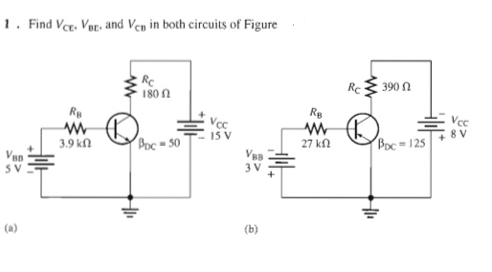
Fig 1

